# Neo4j cloud VMs

## Basics and file Locations

Based on the Ubuntu distribution of Linux

Must not modify the /etc/neo4j/neo4j.conf file directly, but rather modify /etc/neo4j/neo4j.template

The system service that restarts Neo4j calls a shell script called pre-neo4j.sh

## VM configuration

* In cloud environments, much of the external configuration environment may change
* A machine may have a different IP address or a different set of tags when it restarts
* Because of this, the pre-neo4j.sh script dynamically overwrites the normal neo4j.conf file each time the system service starts
* As a result, you must configure the template to do those substitutions and not the configuration file itself, as it will be automatically overwritten.

# Neo4j on Amazon EC2

## Deploying Neo4j on Amazon EC2.

* There are several options for running Neo4j on AWS EC2, depending on what you want to do.

## Host a Single Instance of Neo4j on AWS

1. Open the AWS EC2 console, and select Images > AMIs
2. Search type – **Public Images** instead of Owned by me
3. Search for either "**neo4j-enterprise**"
4. You will know you are using the right one when you see the "Owner" field showing this number: **385155106615**
5. AMI ID should be - **ami-068fb3b64fc6d34ed**
6. Locate the AMI ID and create VM from it

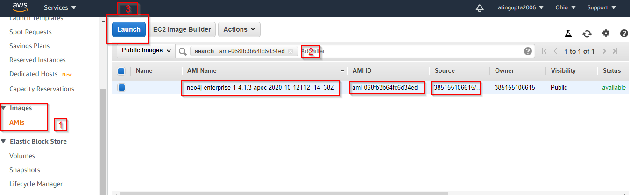

1. Add these ports in network security group - 22 7474 7473 7687

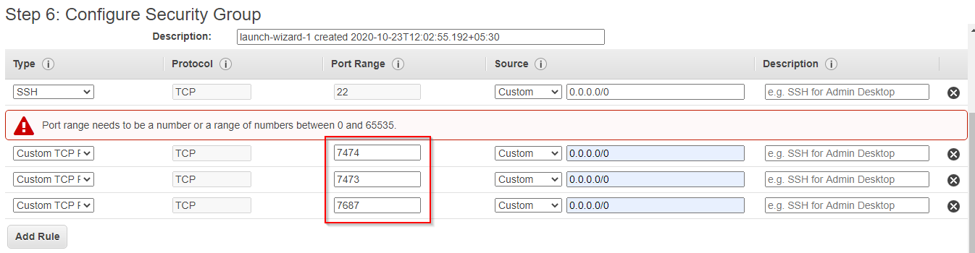

1. **Note:** Make sure to create and download the Private Key
2. Now, let’s navigate to https://[PublicIP]:7474 and login
   1. User name / Password: neo4j/ neo4j.
   2. **Change Password:** secret
3. SSH into the instance
   1. Username - ubuntu
   2. Use Private SSH Key instead of password

# Neo4j on Microsoft Azure

## Single instances

1. **Open:**

<https://azuremarketplace.microsoft.com/en-us/marketplace/apps/neo4j.neo4j-enterprise-4-1-series?tab=Overview>

Deploy VM following the interactive prompts.

1. Note Public IP of the VM
2. **Browse:** http://<Public IP>:7474/browser/
   1. **Username/Password:** neo4j/neo4j
   2. **Change Password:** secret

## Causal Clusters

1. **Open:**

<https://azuremarketplace.microsoft.com/en-us/marketplace/apps/neo4j.neo4j-enterprise-causal-cluster?tab=Overview>

Deploy following the interactive prompts

Create a new resource group to hold the artifacts of your deployment

Note: Use Standard Disk only. Do not chose SSD

1. Note Public IP of any of the VM
2. **Browse:** http://<Public_IP>:7474/browser/
3. **Username/Password:** neo4j/neo4j

### Start using Neo4j Browser

To verify that the cluster has formed correctly, run the following Cypher statement:

CALL dbms.cluster.overview()

### Access your instance via SSH

Use Mabaxterm to login to the VMs